Shooter Game Version Blueprint Code Doc
- ABP_ShooterCharacter
Anim Graph:-
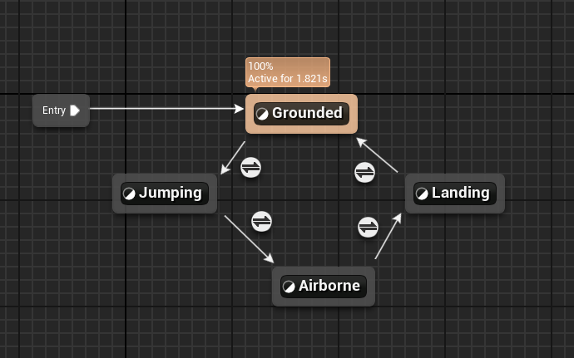
Grounded: -
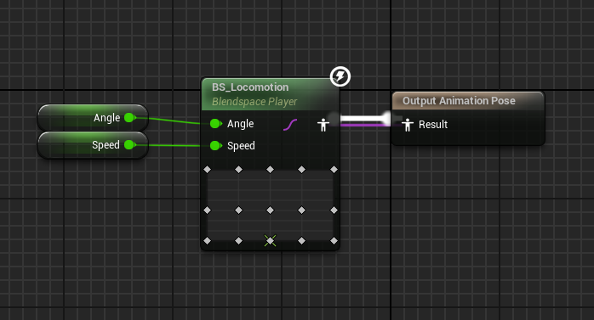
Grounded to Jumping Transition :-
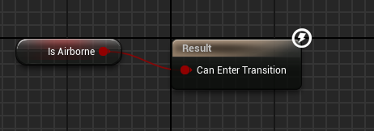
Jumping:-
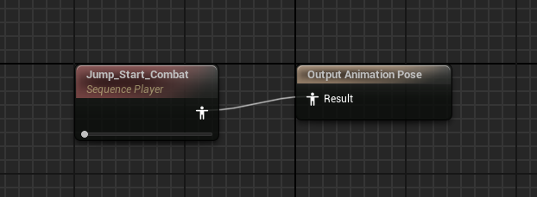
Jumping to Airborne Transition :- Automated
Airborne:-
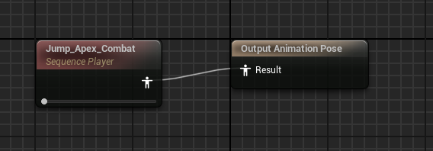
Airborne to Landing Transition:-
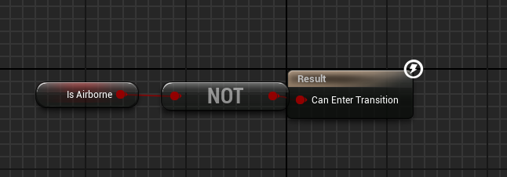
Landing:-
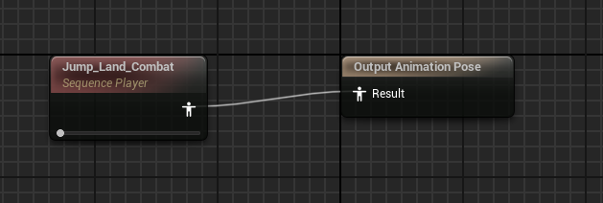
Landing to Grounded:- Automation

Blueprint Graph:-
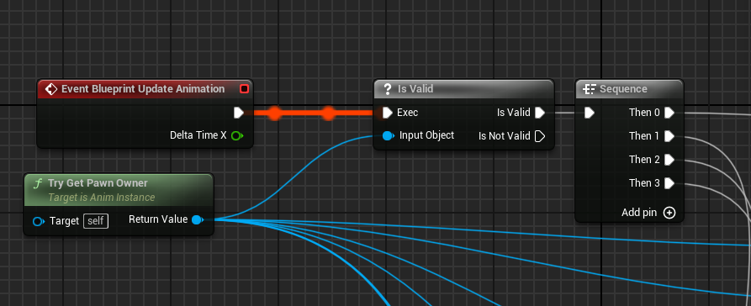
Then 0:-
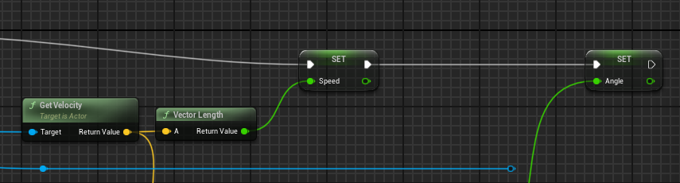
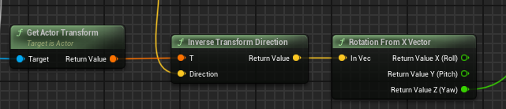
Then 1:-
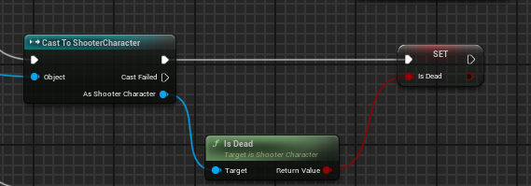
Then 2:-
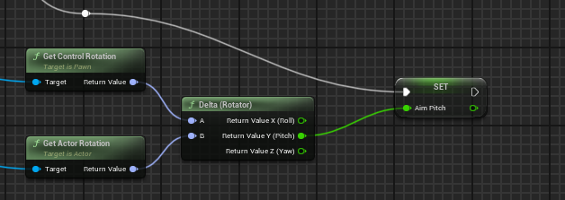
Then 3:-
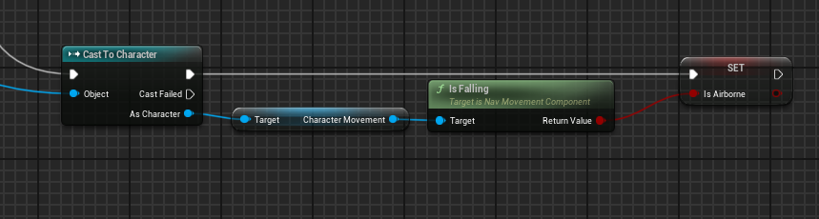
- BP_PlayerShooterCharacter
Blueprint Graph:-
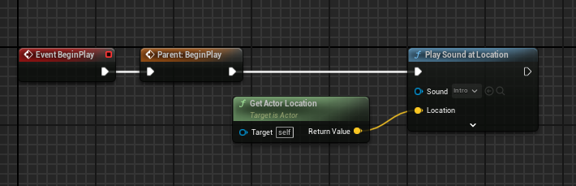
- Ui
- WBP_HUD
Designer:-
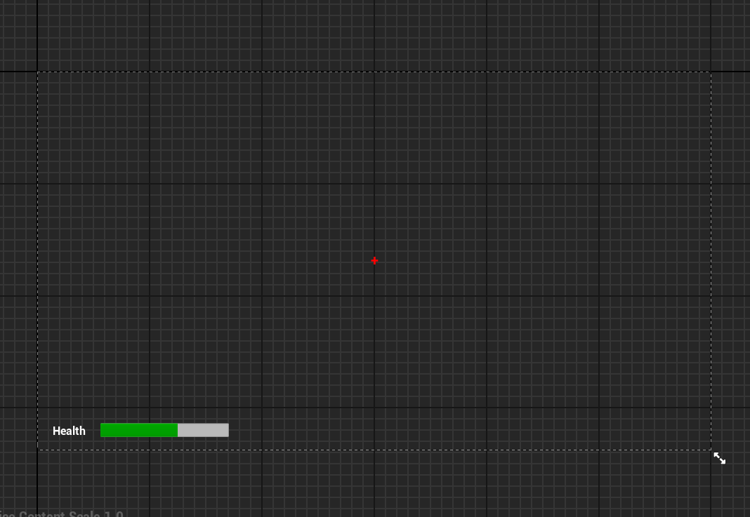
Graph:-
Get Health:-
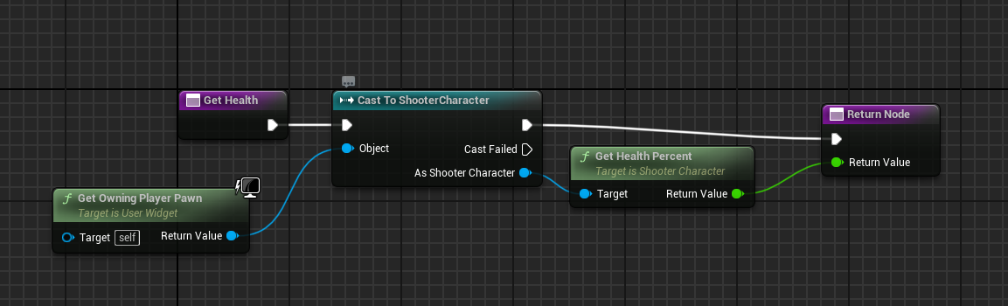
- WBP_LoseScreen
Designer:-
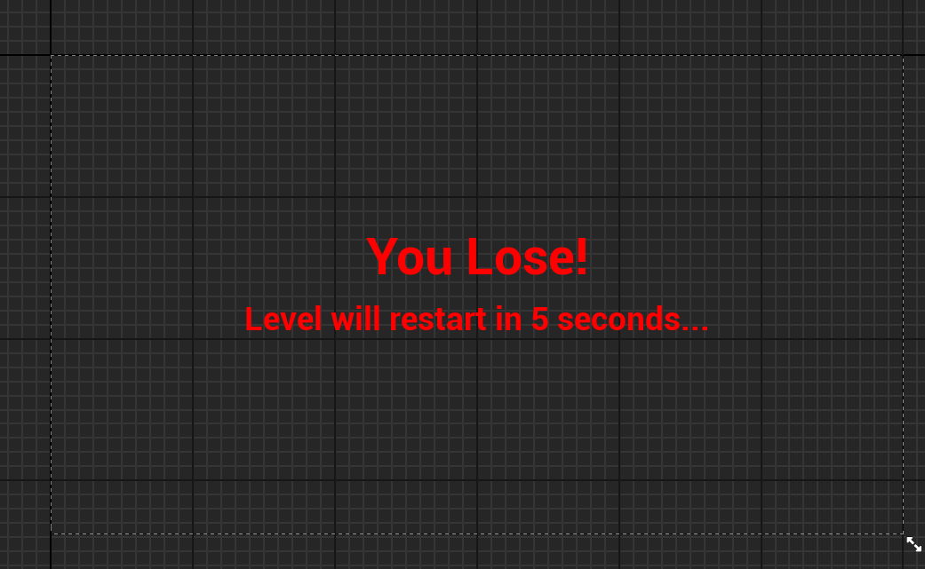
- WBP_WinScreen
Designer:-
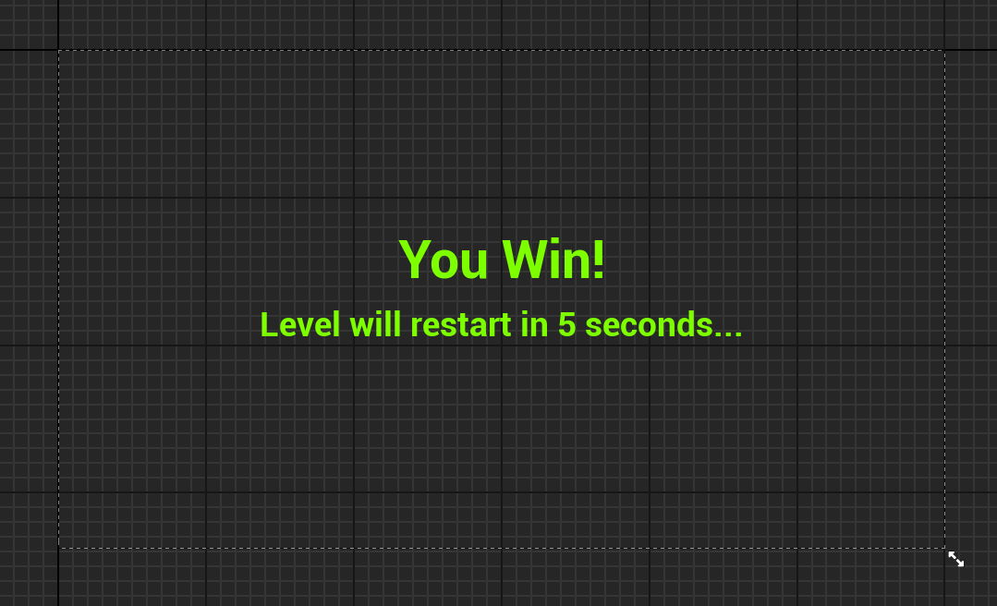
- Ai
- Blackboard
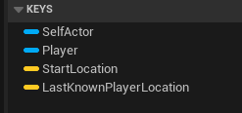
- Behavior Tree
